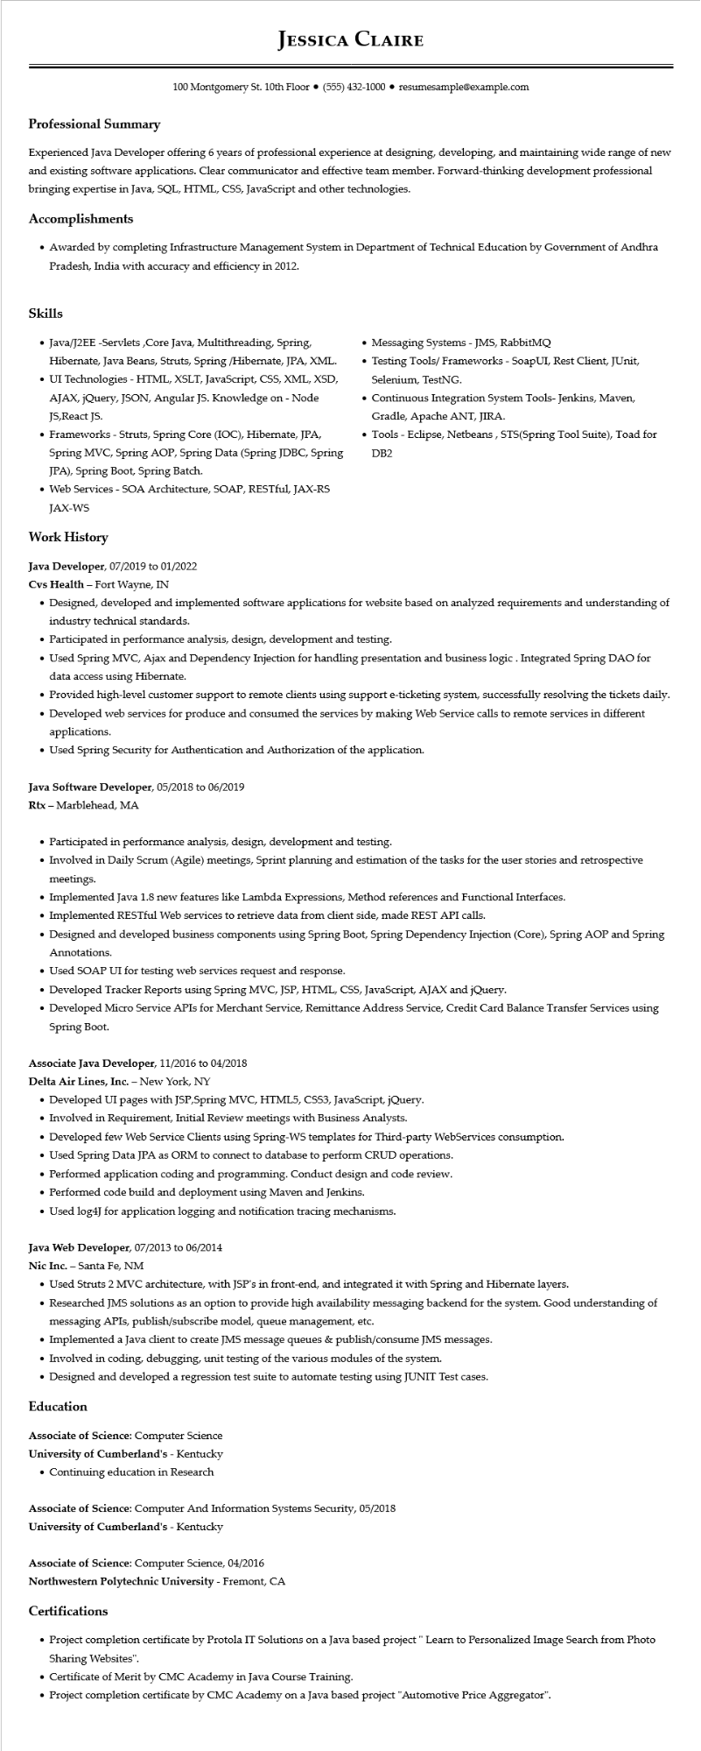
Professional Summary
JESSICA CLAIRE
100 Montgomery St. 10th Floor⚫ (555) 432-1000⚫ resumesample@example.com
Experienced Java Developer offering 6 years of professional experience at designing, developing, and maintaining wide range of new and existing software applications. Clear communicator and effective team member. Forward-thinking development professional bringing expertise in Java, SQL, HTML, CSS, JavaScript and other technologies.
Accomplishments
• Awarded by completing Infrastructure Management System in Department of Technical Education by Government of Andhra Pradesh, India with accuracy and efficiency in 2012.
Skills
• Java/J2EE -Servlets,Core Java, Multithreading, Spring, Hibernate, Java Beans, Struts, Spring /Hibernate, JPA, XML.
• UI Technologies - HTML, XSLT, JavaScript, CSS, XML, XSD, AJAX, jQuery, JSON, Angular JS. Knowledge on - Node JS,React JS.
• Frameworks - Struts, Spring Core (IOC), Hibernate, JPA, Spring MVC, Spring AOP, Spring Data (Spring JDBC, Spring JPA), Spring Boot, Spring Batch.
• Web Services - SOA Architecture, SOAP, RESTful, JAX-RS JAX-WS
Work History
Java Developer, 07/2019 to 01/2022
Cvs Health - Fort Wayne, IN
• Messaging Systems - JMS, RabbitMQ
Testing Tools/Frameworks - SoapUI, Rest Client, JUnit, Selenium, TestNG.
• Continuous Integration System Tools- Jenkins, Maven, Gradle, Apache ANT, JIRA.
• Tools - Eclipse, Netbeans, STS(Spring Tool Suite), Toad for DB2
• Designed, developed and implemented software applications for website based on analyzed requirements and understanding of industry technical standards.
• Participated in performance analysis, design, development and testing.
• Used Spring MVC, Ajax and Dependency Injection for handling presentation and business logic. Integrated Spring DAO for data access using Hibernate.
• Provided high-level customer support to remote clients using support e-ticketing system, successfully resolving the tickets daily.
• Developed web services for produce and consumed the services by making Web Service calls to remote services in different applications.
• Used Spring Security for Authentication and Authorization of the application.
Java Software Developer, 05/2018 to 06/2019
Rtx - Marblehead, MA
• Participated in performance analysis, design, development and testing.
• Involved in Daily Scrum (Agile) meetings, Sprint planning and estimation of the tasks for the user stories and retrospective meetings.
• Implemented Java 1.8 new features like Lambda Expressions, Method references and Functional Interfaces.
• Implemented RESTful Web services to retrieve data from client side, made REST API calls.
• Designed and developed business components using Spring Boot, Spring Dependency Injection (Core), Spring AOP and Spring Annotations.
• Used SOAP UI for testing web services request and response.
• Developed Tracker Reports using Spring MVC, JSP, HTML, CSS, JavaScript, AJAX and jQuery.
• Developed Micro Service APIs for Merchant Service, Remittance Address Service, Credit Card Balance Transfer Services using Spring Boot.
Associate Java Developer, 11/2016 to 04/2018
Delta Air Lines, Inc. - New York, NY
• Developed UI pages with JSP,Spring MVC, HTML5, CSS3, JavaScript, jQuery.
• Involved in Requirement, Initial Review meetings with Business Analysts.
• Developed few Web Service Clients using Spring-WS templates for Third-party WebServices consumption.
• Used Spring Data JPA as ORM to connect to database to perform CRUD operations.
• Performed application coding and programming. Conduct design and code review.
• Performed code build and deployment using Maven and Jenkins.
• Used log4J for application logging and notification tracing mechanisms.
Java Web Developer, 07/2013 to 06/2014
Nic Inc. - Santa Fe, NM
• Used Struts 2 MVC architecture, with JSP's in front-end, and integrated it with Spring and Hibernate layers.
• Researched JMS solutions as an option to provide high availability messaging backend for the system. Good understanding of messaging APIs, publish/subscribe model, queue management, etc.
• Implemented a Java client to create JMS message queues & publish/consume JMS messages.
• Involved in coding, debugging, unit testing of the various modules of the system.
• Designed and developed a regression test suite to automate testing using JUNIT Test cases.
Education
Associate of Science: Computer Science
University of Cumberland's - Kentucky
• Continuing education in Research
Associate of Science: Computer And Information Systems Security, 05/2018
University of Cumberland's - Kentucky
Associate of Science: Computer Science, 04/2016
Northwestern Polytechnic University - Fremont, CA
Certifications
• Project completion certificate by Protola IT Solutions on a Java based project " Learn to Personalized Image Search from Photo Sharing Websites".
• Certificate of Merit by CMC Academy in Java Course Training.
• Project completion certificate by CMC Academy on a Java based project "Automotive Price Aggregator".

